PAMS Test Plan

Manual Testing (GUI / User-based)
These tests are best evidenced through screenshots because they focus on what the user can see and do in the interface. In the screenshot evidence section below, screenshots are provided for some of the test cases to give examples of the system’s behaviour and visual output. Each example includes a short explanation with the related screenshot placed directly underneath, so the evidence is clearly connected to the test case.

Test Case # | Description | Test dataset/Input | Expected output | Actual output
1 | Create tenant and user records | Role-based input data | Records are created successfully according to assigned roles | As expected
2 | Validate required registration fields | Complete valid data | All mandatory fields are accepted and validated | Pending
3 | Validate invalid tenant and user data | Invalid or missing data | System prevents saving and displays validation errors | As expected
4 | Update tenant and user records | Modified record details | Changes are saved correctly | As expected
5 | Delete tenant and user records | Existing tenant/user record | Selected record is removed successfully | As expected
6 | Tenant inquiry by city | Front-desk user searches assigned-city tenant | Correct tenant shown; no other-city data | Pending
7 | Tenant list by city | Open tenant list | Only assigned-city tenants visible | Pending
8 | Cross-city tenant access blocked | Open tenant from another city | Access denied | Pending
9 | Tenant reference management | Add, update reference email | Reference details saved under system rules | Pending
10 | Duplicate email prevention | Reuse tenant/reference email incorrectly | Duplicate misuse blocked; no repeated notifications | Pending
11 | Maintenance requests by city | Add or open maintenance requests | Saved correctly; only assigned-city requests shown | Pending
12 | Complaints by city | Add complaint and open complaint list | Complaint linked correctly; city restriction applied | Pending
13 | Finance dashboard cards | Open finance dashboard | Only finance cards shown | Pending
14 | Finance data by city | Review totals and graphs | All finance values use assigned city only | Pending
15 | Payments list by city | Open payments management | Only assigned-city payments shown | Pending
16 | Generate invoice | Create invoice | Invoice generated successfully | As expected
17 | Invoice/receipt download | Download invoice or billing receipt | Correct file generated and downloaded | Pending
18 | Record payment | Mark invoice paid | Payment status updates correctly | As expected
19 | Late payment UI | Open overdue payment | Late status and notification shown correctly | Pending
20 | Maintenance dashboard by city | Open maintenance dashboard | Only assigned-city maintenance data visible | Pending
21 | Maintenance investigation/priority | Investigate issue and set priority | Investigation opens; priority saves correctly | Pending
22 | Scheduling and availability | Schedule approved request | 3 time slots shown; schedule saved | Pending
23 | Resolution and logging | Resolve request with notes, time, cost | Status and resolution details saved | Pending
24 | Admin records by city | Open user/admin records | Only assigned-city records accessible | Pending
25 | Admin apartment management | Add or update apartment | Admin manages apartments for assigned city only | Pending
26 | Admin reports and lease end dates | Generate report; review lease end dates | Reports limited by city; end dates tracked | Pending
27 | Manager property/apartment view | Open property and apartment lists | Allowed records shown correctly | Pending
28 | Apartment status update | Set Available/Not available/Occupied | Status saves and displays correctly | Pending
29 | Add building or new city, then open forms and filters | Valid city/building data saved; new city | Building/city appears in forms and filters and can be used | Pending
30 | Lease creation validation | Create lease with tenant, apartment, dates, rent | Lease saves only with valid values | Pending
31 | Lease ending / tenant deletion | End early or delete tenant with lease | Notice shown; linked leases handled correctly | Pending
32 | Occupancy/performance reports | Open manager reports | Correct reports shown for relevant location | Pending
33 | Report filters | Apply Late, Paid, Building, City, Period | Results update correctly | Pending
34 | Combined city/building filters | Apply city + building filters | Displayed data matches both filters | Pending
35 | All report views | Open occupancy, financial, maintenance reports | Correct report data displayed | As expected
36 | RBAC UI test | Open page outside role permissions | Access denied | As expected
37 | Login routing | Log in with different roles/cities | Correct interface opens for role and city | Pending
38 | Correct logged-in user | Log in as different users | Correct user details shown | Pending
39 | Logout flow | Logout and revisit protected page | Access blocked | As expected
40 | Navigation/back button | Switch pages and go back | Navigation works correctly | As expected
41 | Show password toggle | Toggle password while typing | Password visibility changes correctly | Pending
42 | Sidebar/dashboard toggle | Use toggle button | Interface toggles without layout issues | Pending
43 | Error messages | Trigger invalid form input | Clear validation messages shown | As expected
44 | Data refresh in same session | Update data and reopen page | Latest data appears without restart | Pending
45 | Window responsiveness | Resize app window | Layout remains clear and usable | Pending
46 | Extremely long input (UI) | Enter 1000+ characters in text fields | Input is rejected or trimmed with clear message | Pending
47 | SQL-like input (UI) | Enter ' OR 1=1 in input fields | Input is sanitised or rejected with error | Pending
48 | Negative rent input (UI) | Enter negative value for rent | Validation error shown | Pending
49 | Invalid date format (UI) | Enter text instead of date | Validation error shown | Pending
50 | Empty required fields (UI) | Submit form with missing fields | Required field errors displayed | Pending

Test Case 7: Tenant list by city
This manual test checks that tenant records are filtered correctly by city. The screenshot shows the tenant list page displaying only tenants for the assigned location. This supports the expected role and city restriction behaviour by confirming that cross-city tenant data is not visible to the user.
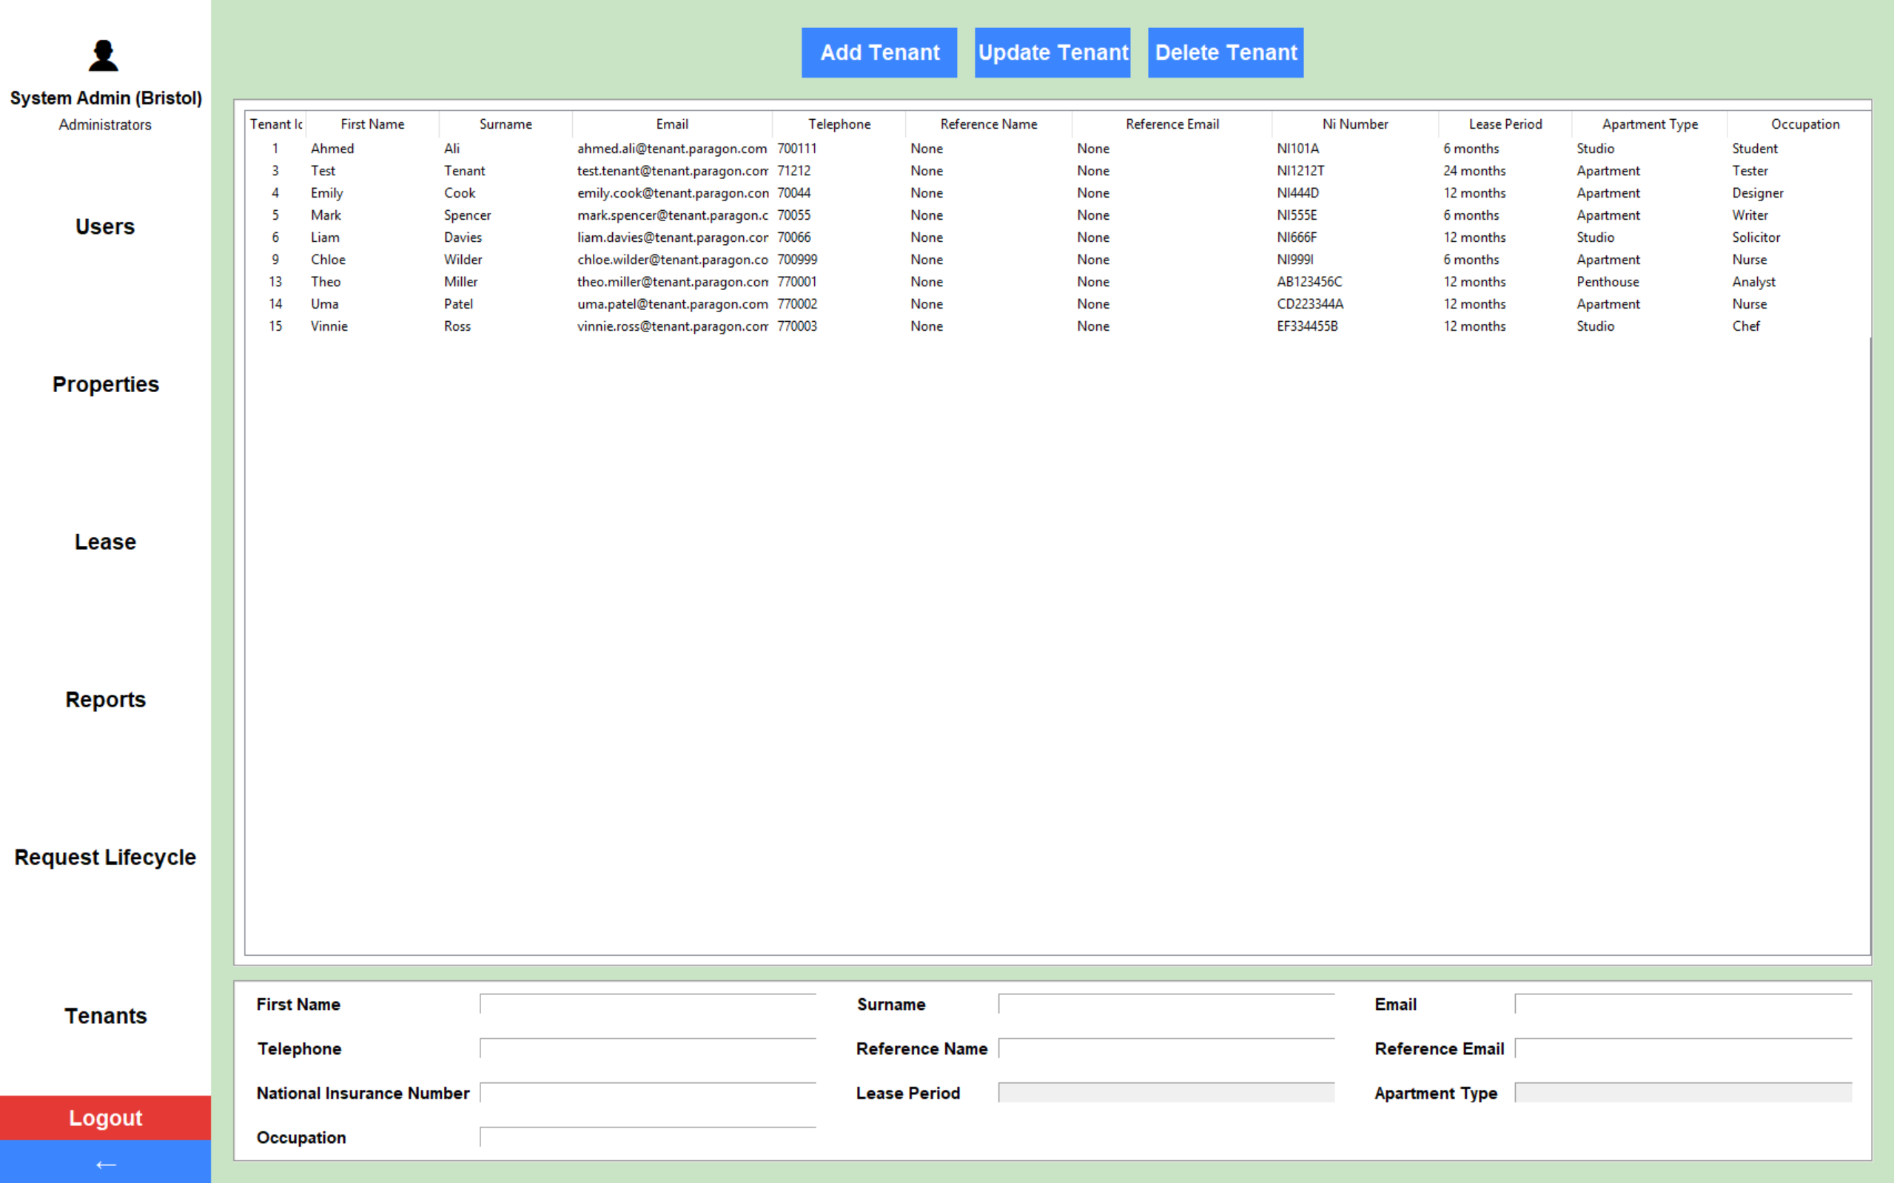
Figure 1 – Screenshot evidence for Test Case 7

Test Case 14: Finance data by city
This manual test checks that finance totals, payment figures, and graphs are displayed for the assigned city only. The screenshot shows the finance report snapshot and financial summary for one location, demonstrating that the dashboard is restricted to the correct city data.
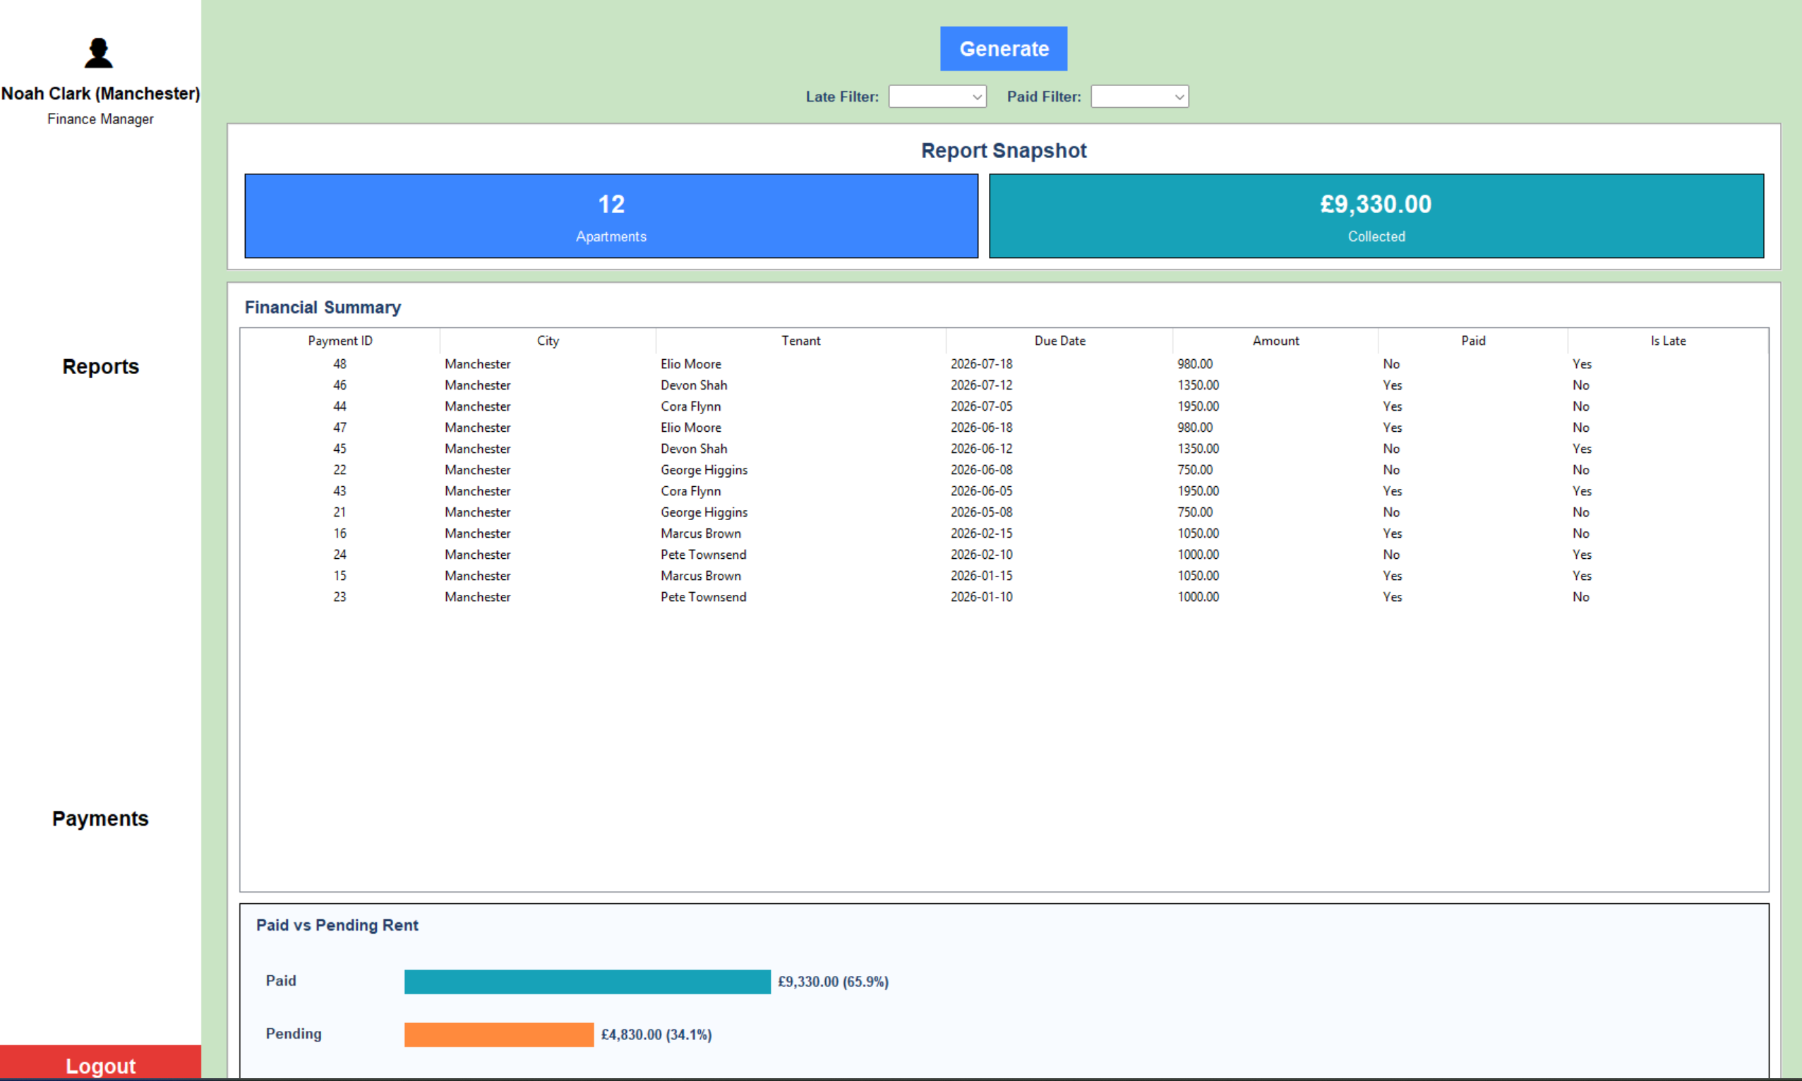
Figure 2 – Screenshot evidence for Test Case 14

Test Case 21: Maintenance investigation and priority
This manual test checks that a maintenance issue can be reviewed and that the investigation workflow functions correctly. The screenshots show the maintenance records view and the maintenance request form with a success message, providing evidence that the issue can be opened, processed, and saved successfully.
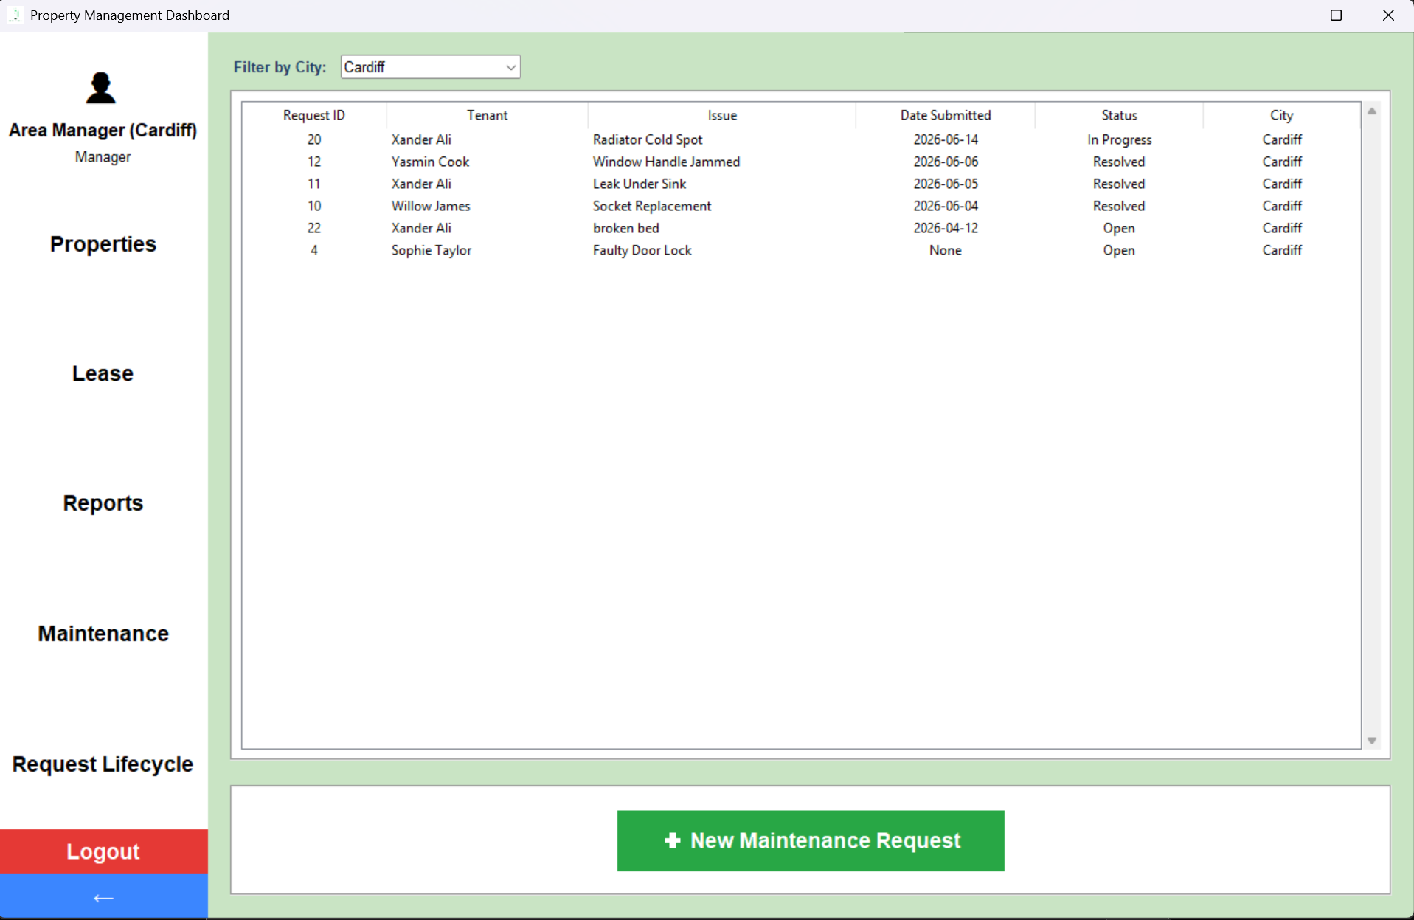
Figure 3.1 – Screenshot evidence for Test Case 21

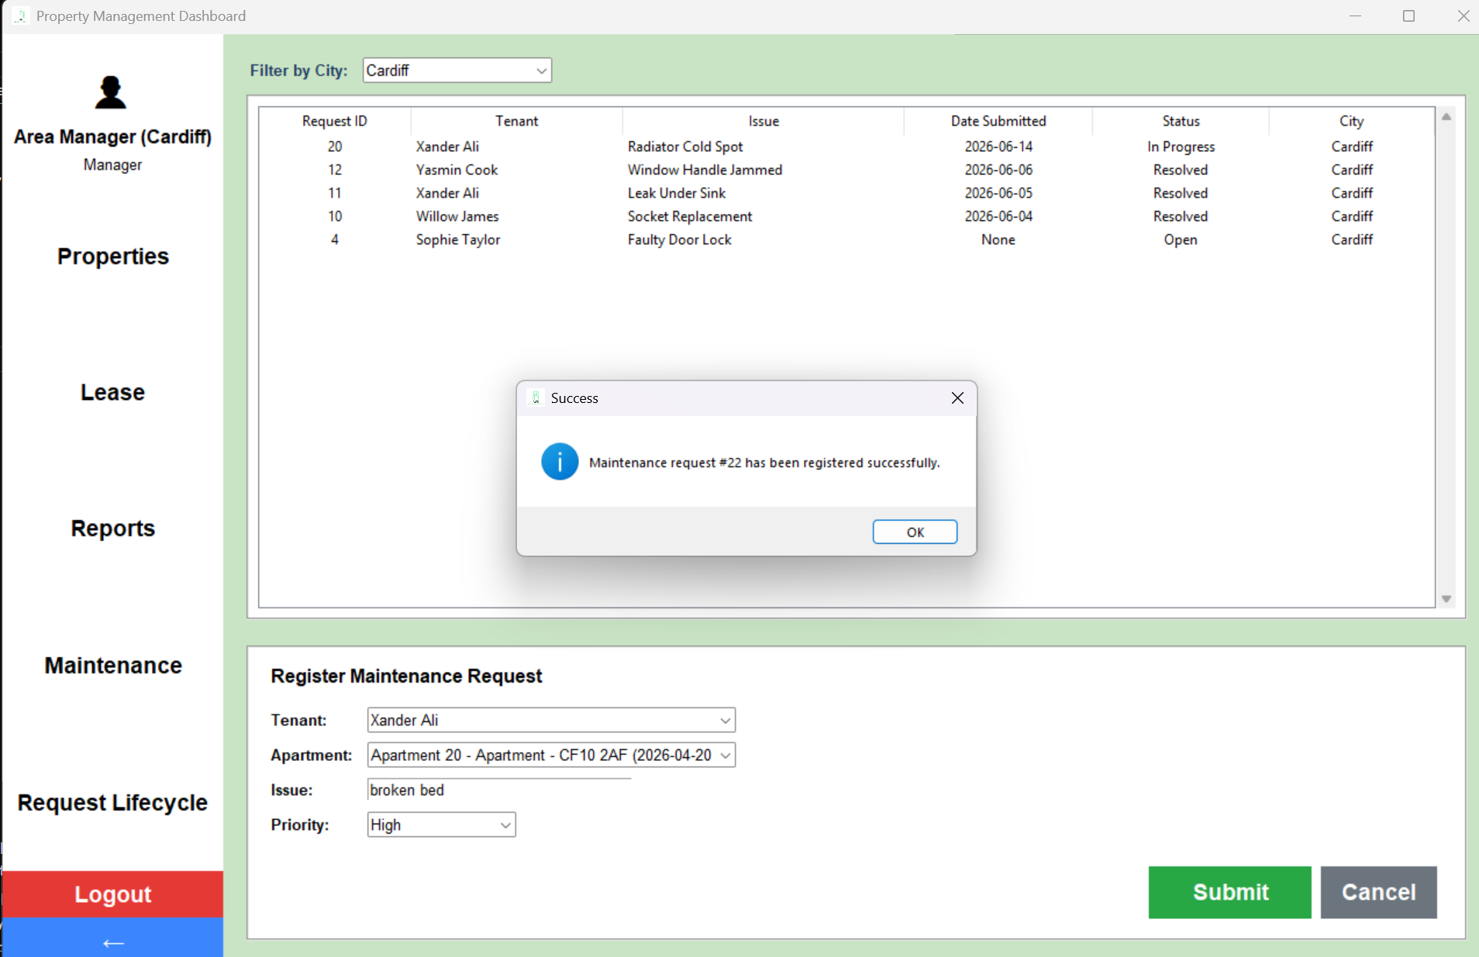
Figure 3.2 – Screenshot evidence for Test Case 21

Test Case 35: All report views
This manual test checks that the system can display the main report views correctly. The screenshots show financial, occupancy, and maintenance report views. Together they demonstrate that the report module can load different report types and present the correct data for each category.
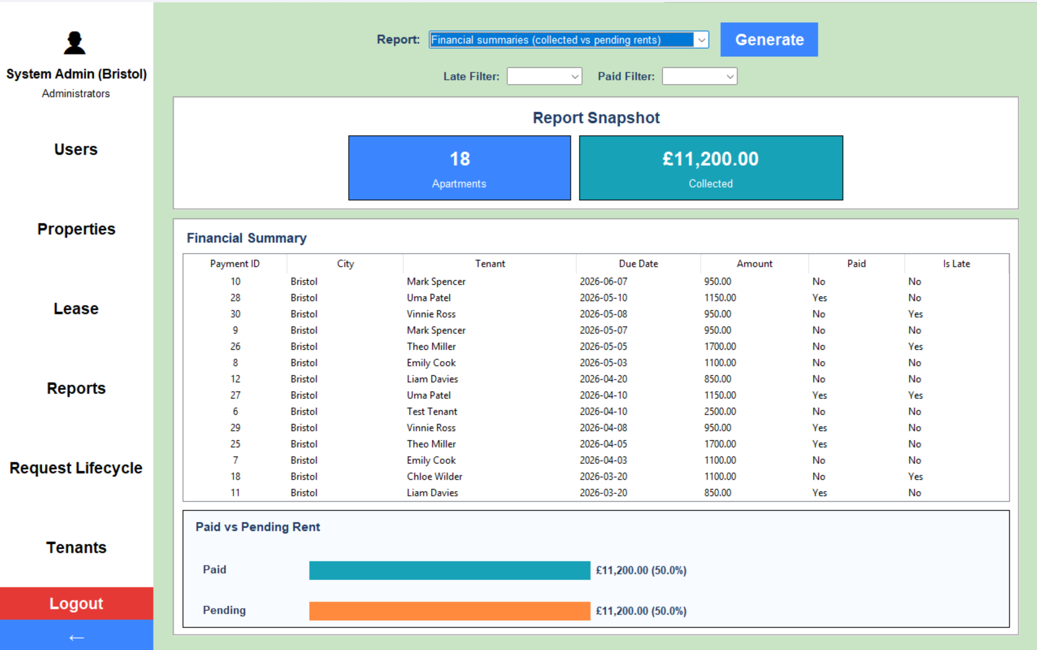
Figure 4.1 – Screenshot evidence for Test Case 35

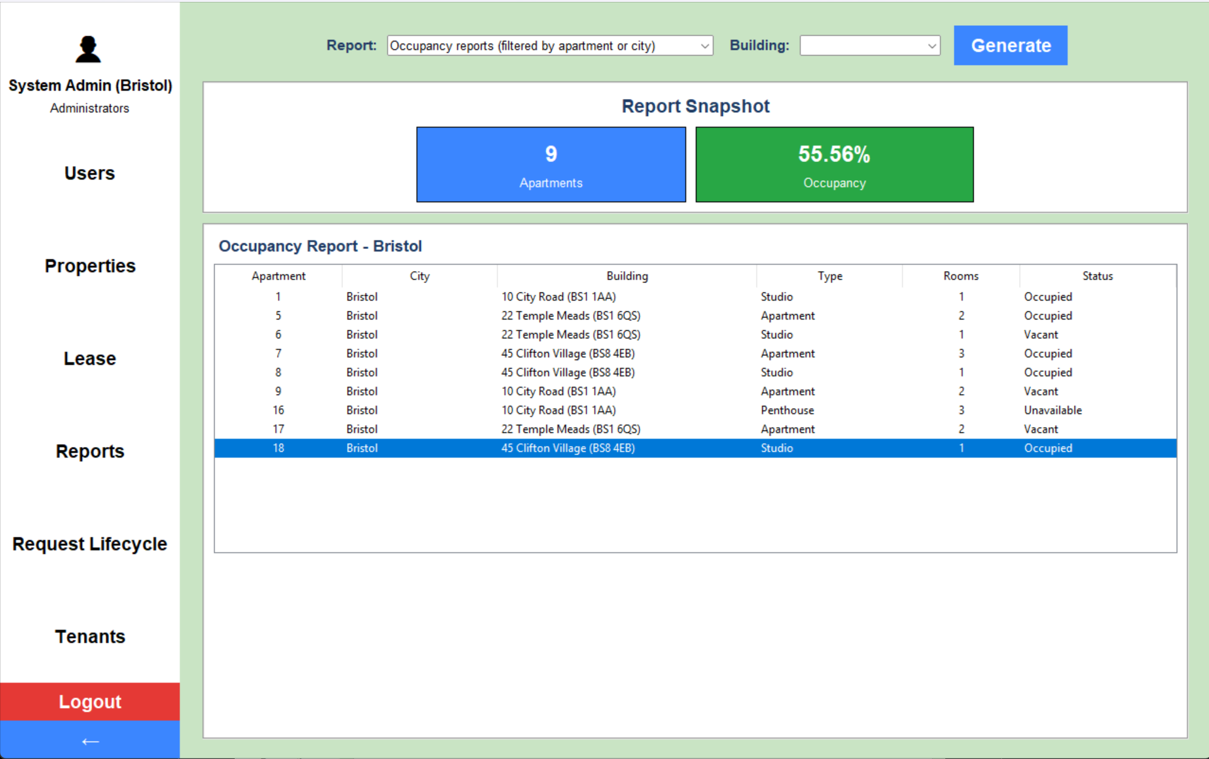
Figure 4.2 – Screenshot evidence for Test Case 35
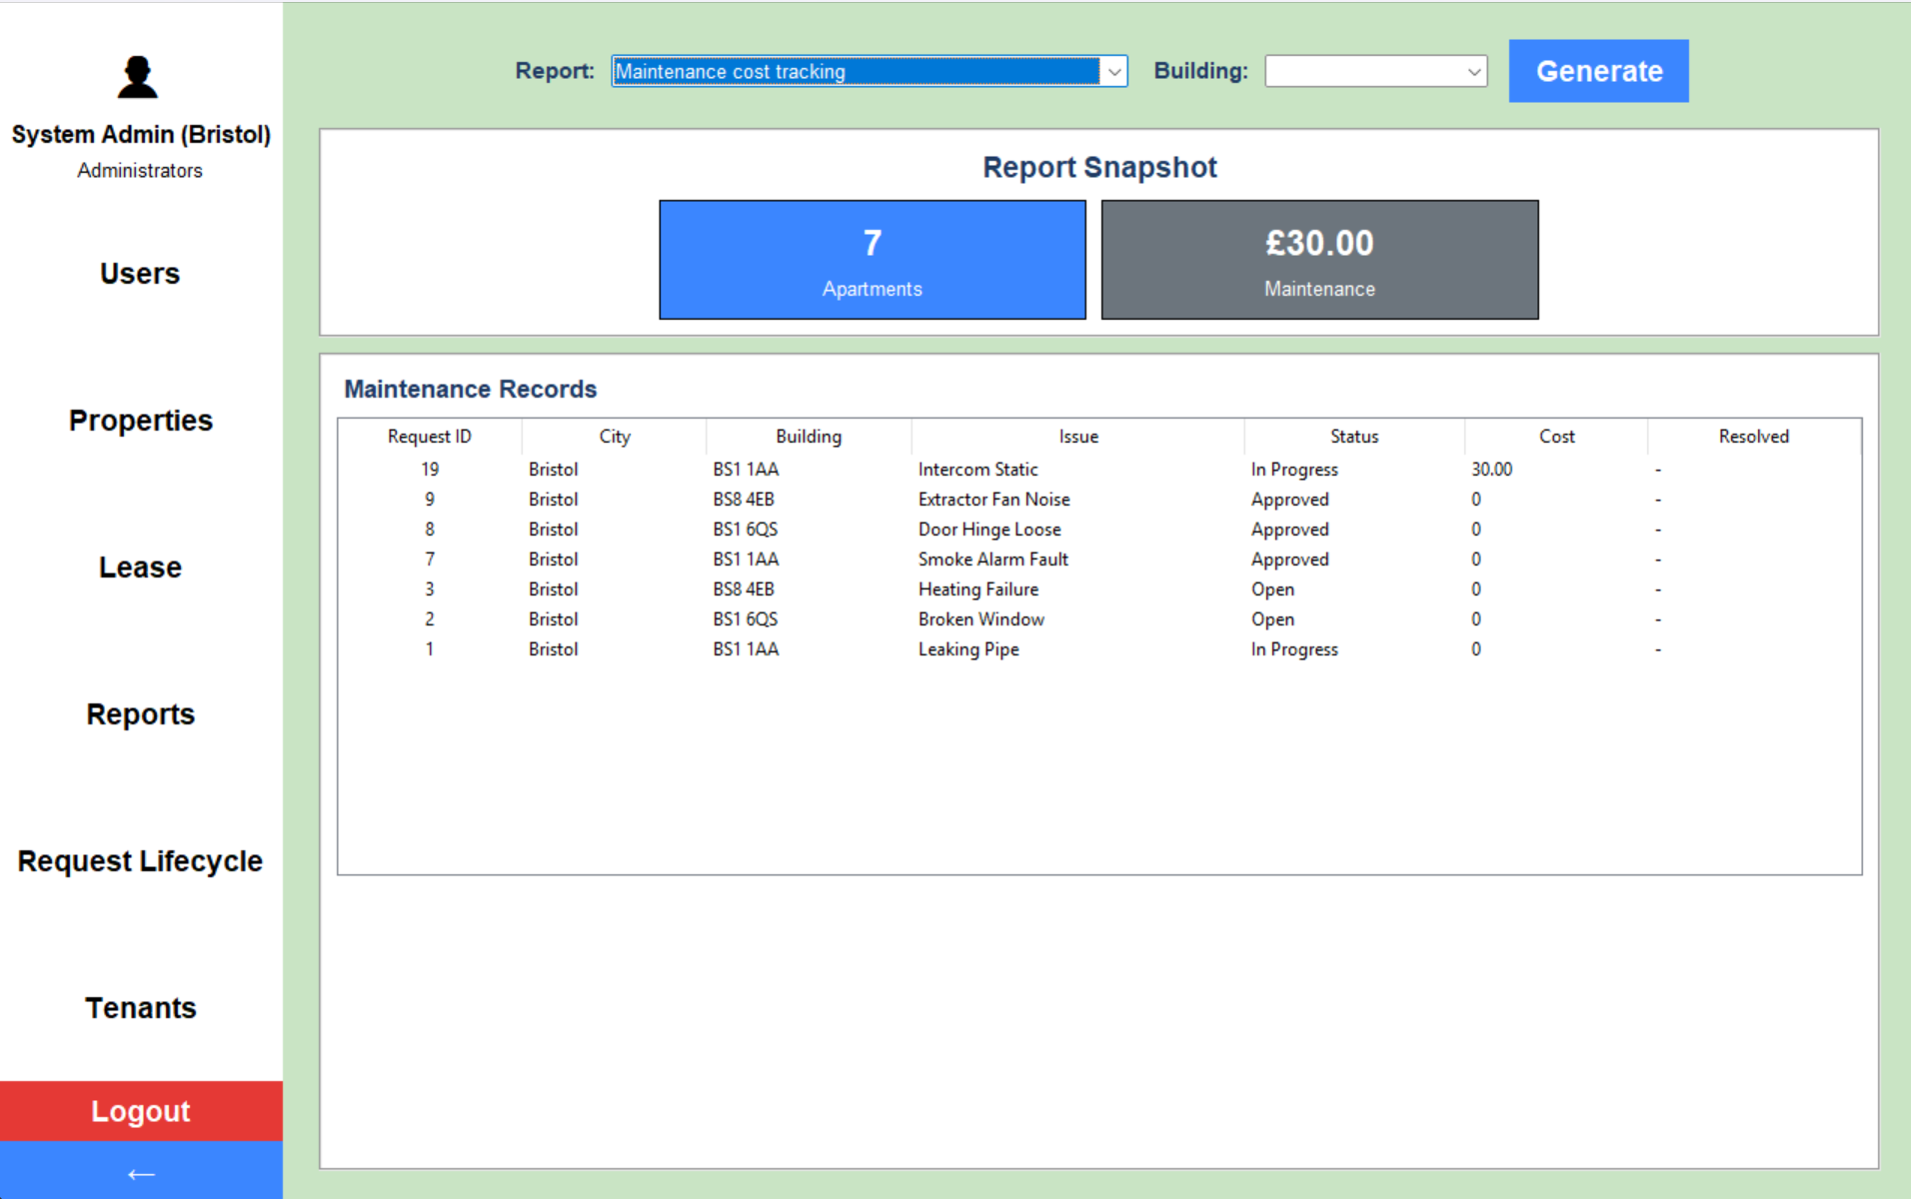
Figure 4.3 – Screenshot evidence for Test Case 35

Test Case 41: Show password toggle
This manual test checks that the show password toggle works correctly on the login page. The screenshots show the login interface before and after the password visibility is toggled, demonstrating that the password field changes visibility as expected while typing.
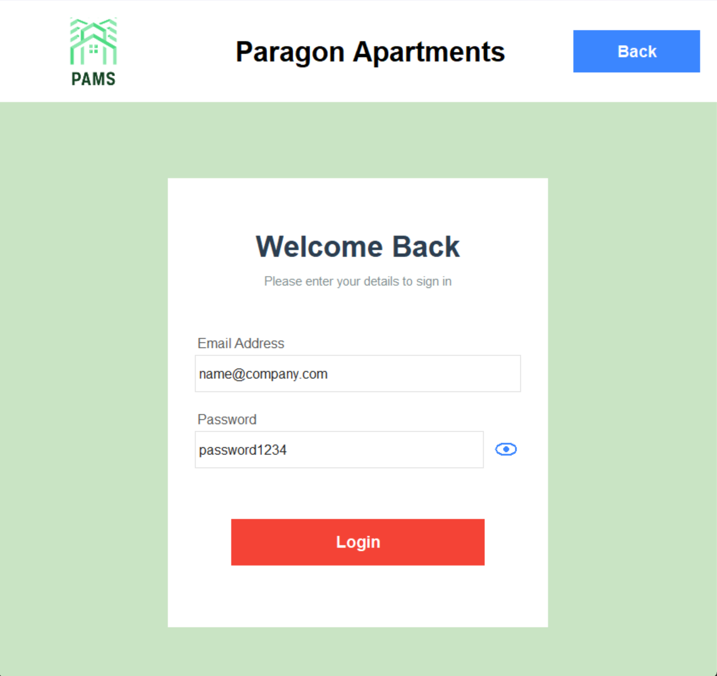
Figure 5.1 – Screenshot evidence for Test Case 41
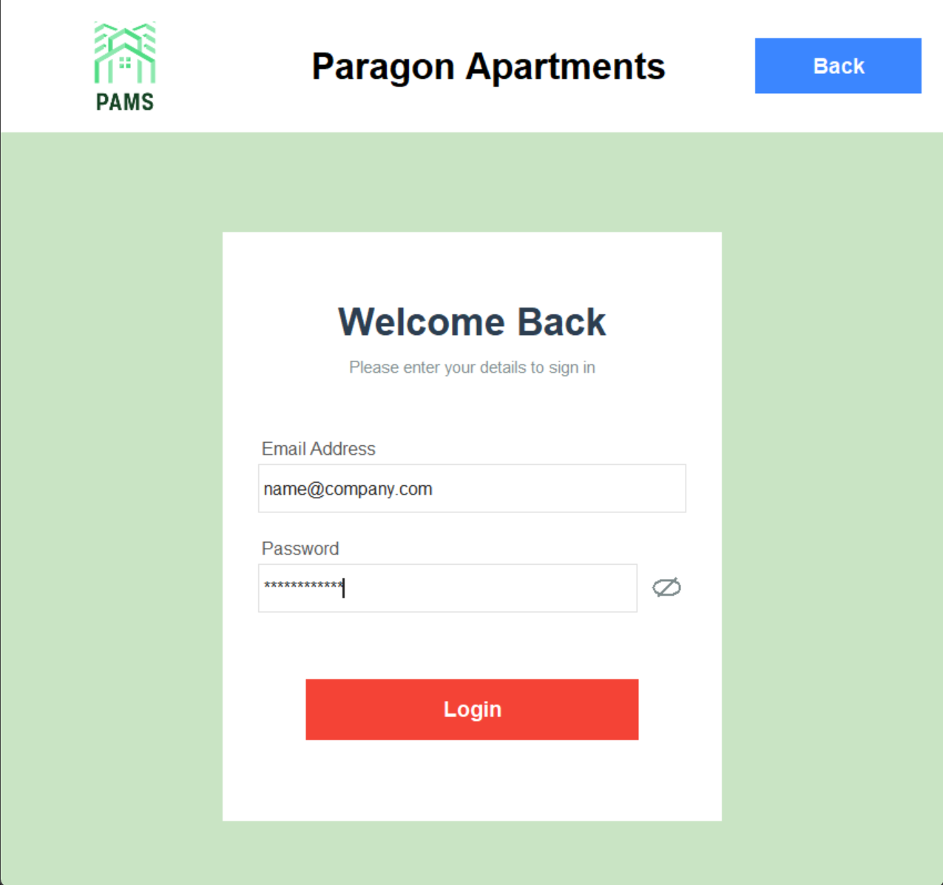
Figure 5.2 – Screenshot evidence for Test Case 41

Test Case 48: Negative rent input
This manual test checks that invalid negative rent values are rejected by the system. The screenshot shows an apartment or lease-related form where an invalid rent entry triggers a validation message, demonstrating that negative rent input is not accepted.
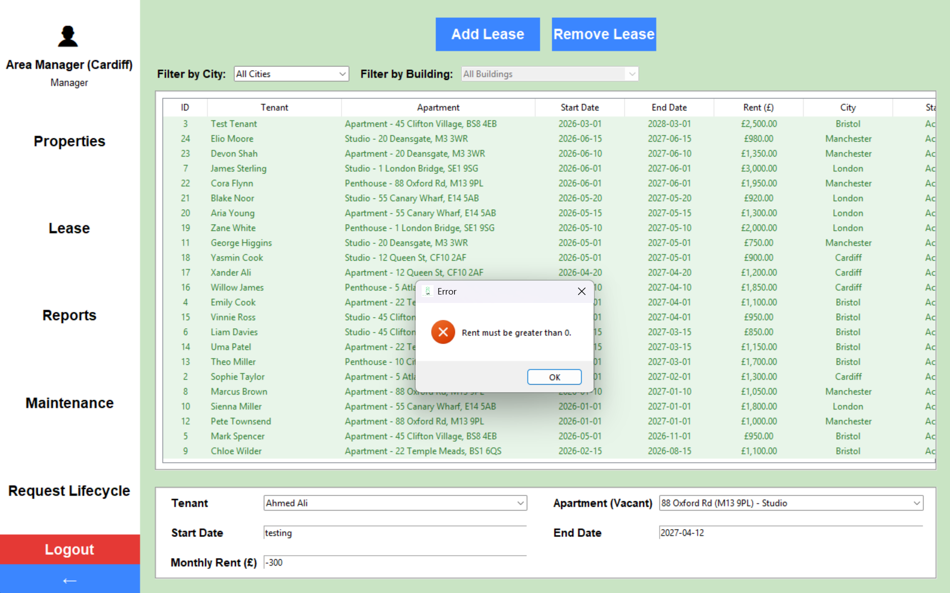
Figure 6 – Screenshot evidence for Test Case 48

Automated Testing (Code / CI Circle)
This section presents the automated testing evidence for the PAMS system. All automated tests were run through CircleCI, which was used to execute the test suites and record the results in the pipeline.
The automated testing evidence is divided into three main sections:
Unit Testing – used to check individual functions, validation rules, and small parts of the system in isolation.
Class Testing – used to test class-level behaviour, internal logic, and how related methods work together inside each component.
Integration Testing – used to verify that connected parts of the system work correctly together across complete workflows.
Together, these sections show how CircleCI was used to identify failures, confirm fixes, and provide clear evidence that the system was tested automatically.
The following sections show pipeline evidence and test-run screenshots for automated verification in CircleCI:

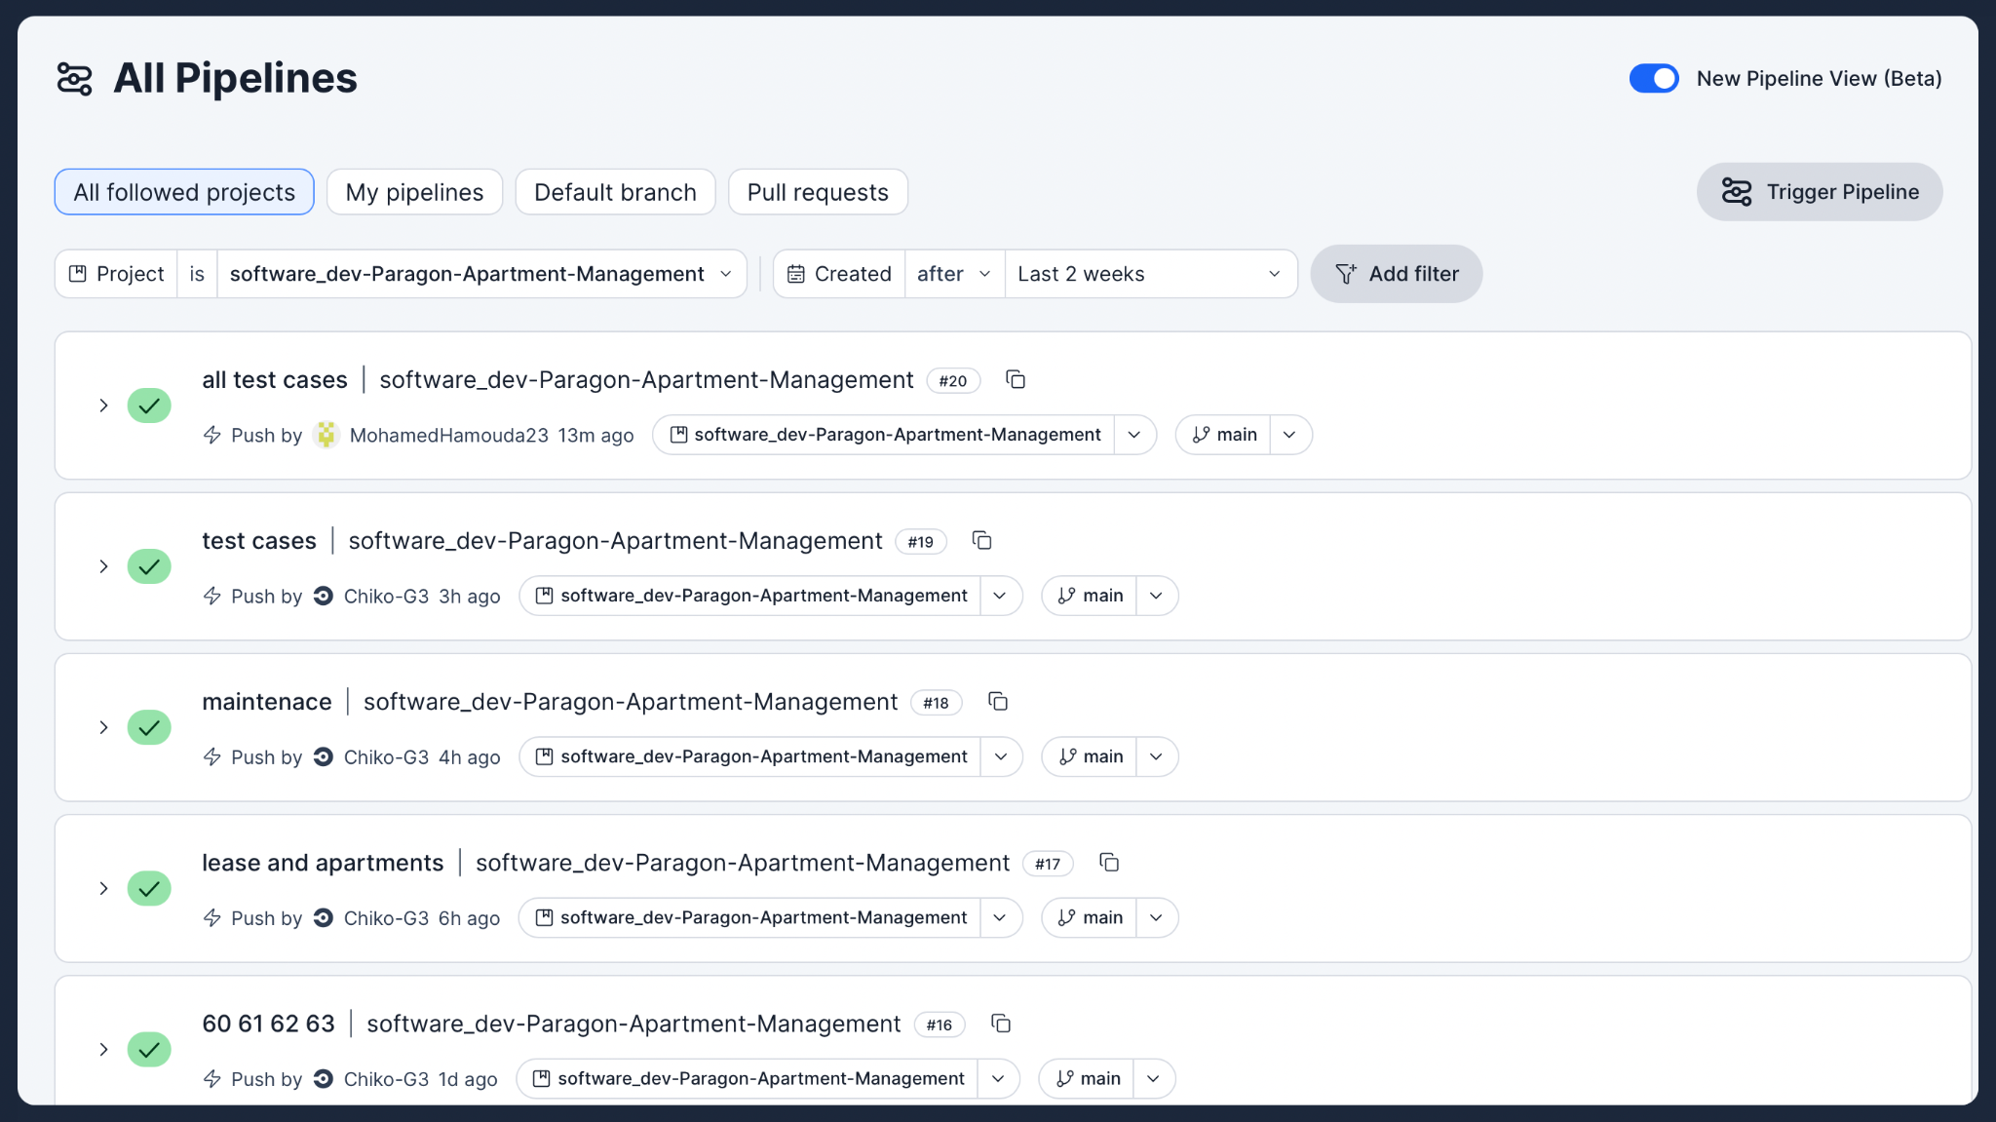
Figure 7.1 – CircleCI pipeline list showing recent PAMS test pipelines.

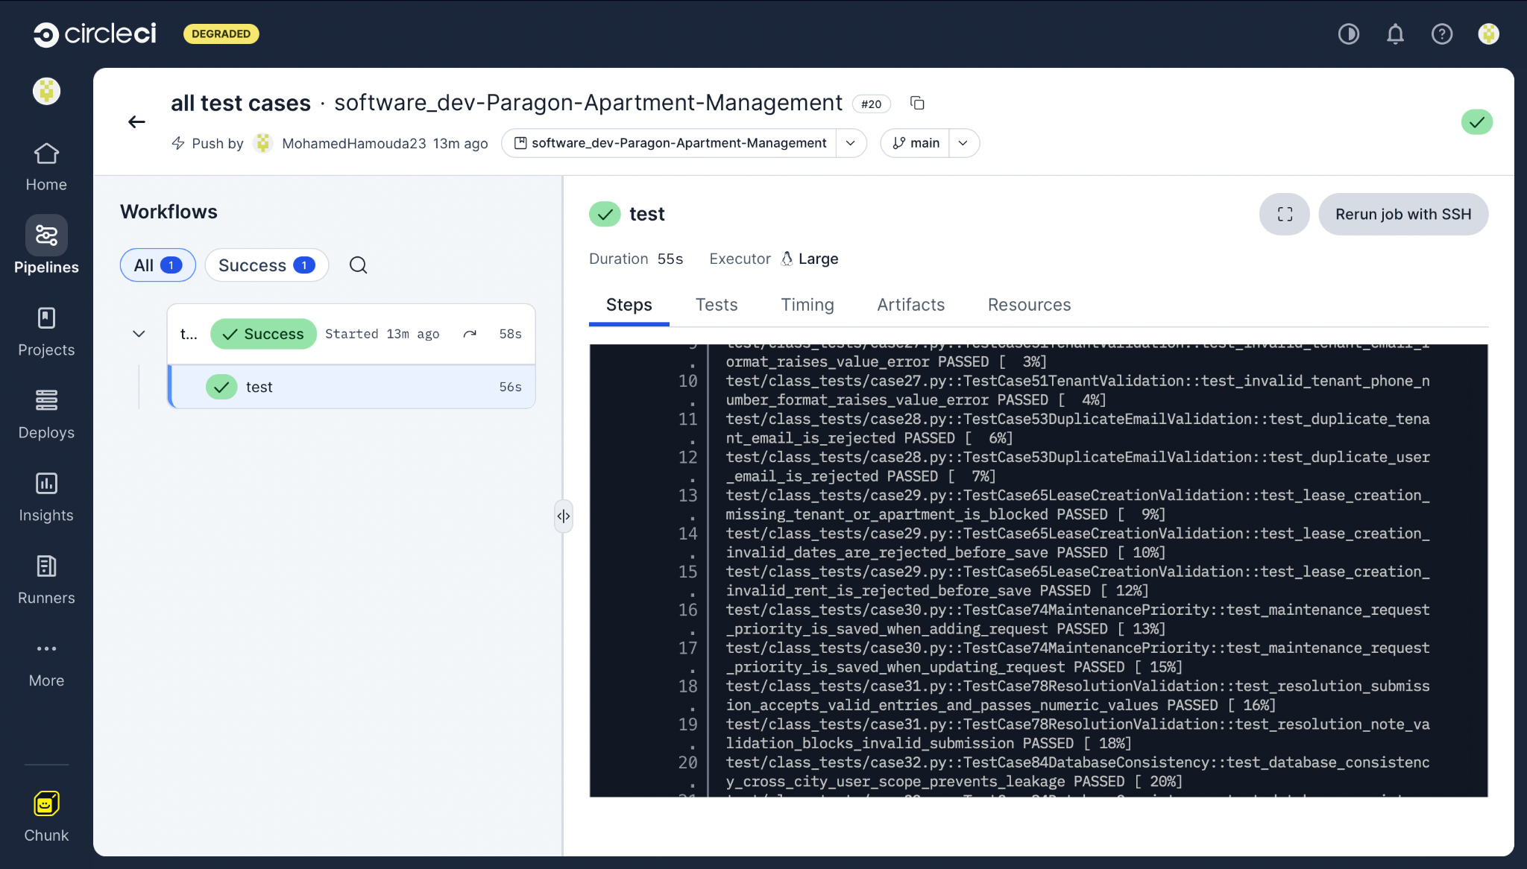
Figure 7.2 – CircleCI pipeline details page for the all test cases workflow.

unit Testing

In unit testing, Figure 8 shows an earlier test run before the fixes were applied. One example of the failed cases was Case 6 and Case 8, which failed due to issues in permission handling, session control, and dashboard access behaviour in the dashboard page implementation. These issues were then resolved, and Figure 4 shows the updated unit test run with the previously failing cases now passing.

Test Case # | Description | Test dataset/Input | Expected output | Actual output
1 | Duplicate NI check | Same NI twice | Blocked | Failed
2 | Reference email rules | Reuse reference email or be blank | Allowed only where rules permit | Pass
3 | Email validation | Invalid email format (without `@` and without symbols) | Rejected | Pass
4 | Password validation | Invalid password format (uppercase, symbol, lowercase, and numbers). | Rejected | Pass
5 | Login authentication | Valid or invalid credentials | login successfully | Pass
6 | Permission matrix | Run allowed/disallowed role actions on manager and administrator | Access follows role, city, permissions | Failed
7 | City restriction logic | Try view another-city data | Restricted | Pass
8 | Session security | Reuse invalid session | Blocked | Failed
9 | Maintenance request validation | Missing required fields | Validation error; request not saved | Pass
10 | Front-desk staff complaint submission | Submit tenant complaint | Complaint is saved successfully | Pass
11 | Apartment validation | Enter invalid apartment details or wrong format | Rejected | Pass
12 | Building/city validation | Missing or invalid building/city data | Invalid input blocked | Pass
13 | Lease date rules | Start date after end date / bad format | Invalid dates blocked | Failed
14 | Tenant deletion cascade | Delete tenant with linked leases | Linked leases handled correctly | Pass
15 | Lease end-date tracking | current/expired lease dates | Lease end dates returned correctly | Pass
16 | early termination request | Rent + penalty(5%) | Correct total calculated with 1 month notice | Pass
17 | Late payment logic | Due date passed with no full payment | Marked late | Pass
18 | Payment status update | Set paid, unpaid, partial cases | Updated status | Pass
19 | Finance report restriction | Open reports as finance manager | Only financial report options available | Pass
20 | Finance city restriction | Open finance data for one city user | Only assigned-city data returned | Pass
21 | Employee selection logic | Assign request to employee | Correct employee linked | Pass
22 | Availability logic | Open scheduling | Only available slot options are returned correctly. | Pass
23 | Lifecycle restriction | Assign/schedule unapproved request | Blocked until approved; city rules enforced | Pass
24 | Mark as resolved on submit | Submit valid resolution | request is marked as Resolved and only valid entries are accepted | Failed
25 | Admin apartment permissions | Admin create /view across cities | Assigned-city admin rules enforced | Pass
26 | Manager report access | Access to generate all reports as Manager | All report types are available to generate | Pass

Figure 8.1 – Earlier unit test run showing failing permission and session-related cases.

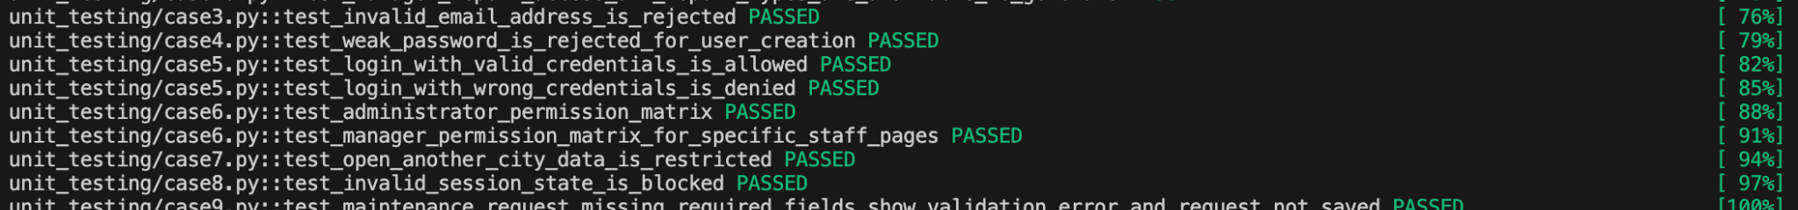
Figure 8.2 – Updated unit test run showing the previously failing unit tests now passing.

Class Testing

In class testing, Figure 9 shows an earlier test run before the fixes were applied. One example of the failed cases was Case 36, where the lifecycle filter logic did not return the correct results due to an issue in the system filter handling. This issue was then resolved, and Figure 6 shows the updated class test run with the previously failing case now passing.

Test Case # | Description | Test dataset/Input | Expected output | Actual output
27 | NI, phone, and email format validation | Enter invalid NI, phone number with letters, and incorrect email format | System rejects all invalid formats and shows validation errors | Pass
28 | email uniqueness | Reuse existing email for both users and tenant | Duplicate email rejected | Pass
29 | Lease creation validation | Invalid tenant, apartment, date, or rent | Lease saves only when valid | Pass
30 | Maintenance priority logic | When add or update request low/medium/urgent priorities | Priority values saved correctly | Failed
31 | Resolution note validation | Validate time and cost inputs and ensure notes meet the minimum word count. | Submission is blocked if the input is invalid | Pass
32 | Database consistency | Cross-city checks | No duplicates or leakage | Pass
33 | Data integrity | Insert invalid/conflicting data | Blocked | Pass
34 | Performance test | Bulk load | No crash | Pass
35 | Scalability test | Large dataset | Stable | Pass
36 | Filter logic across roles | Apply all filters in role views | Each filter updates results correctly | Failed

Figure 9.1 – Class test run showing filter logic coverage with one failing lifecycle result case.

Figure 9.2 – Class test run showing the relevant class tests passing after fixes.

Integration Testing

In integration testing, Figure 10 shows an earlier test run before the fixes were applied. One example of the failed cases was Case 41, where the approval-before-assignment workflow did not correctly block assignment before request approval due to an issue in the maintenance workflow control logic. This issue was then resolved, and Figure 8 shows the updated integration test run with the previously failing case now passing.

Test Case # | Description | Test dataset/Input | Expected output | Actual output
37 | RBAC integration workflow | Run actions across all five roles | Only allowed actions succeed | Failed
38 | Integration: Tenant → Lease → Payment | Create tenant, assign lease, generate payment | Data linked correctly | pass
39 | Integration: Login → RBAC → Dashboard | Login with different roles | Correct dashboard + permissions applied | pass
40 | Early termination penalty and vacate date | Request early termination for an active lease before end date | 5% of monthly rent is applied and vacate date is set to today + 30 days | pass
41 | Request must be approved before assign and schedule | Try to assign staff to a maintenance request that has not been approved | Assign and schedule action is blocked | Failed
42 | Scheduling slots reduce after booking | Schedule one approved request for a staff member on a selected date and slot, then open scheduling for another request for the same staff member and date | Previously booked slot is no longer available and only the remaining slots are shown | Failed

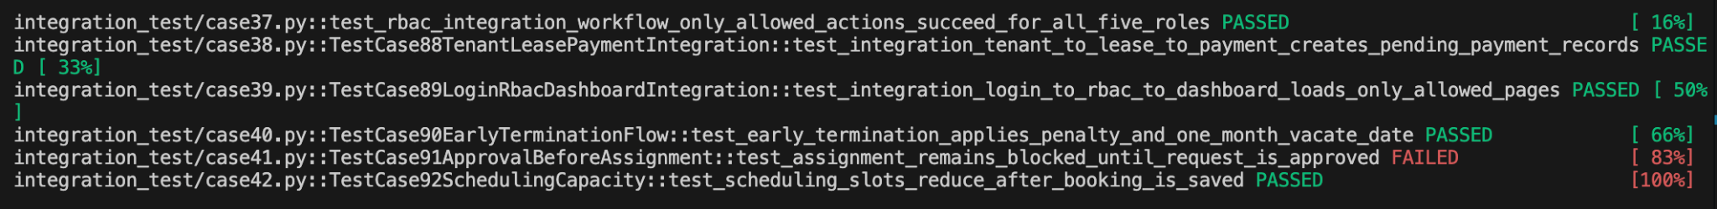
Figure 10.1 – Integration test run showing the approval-before-assignment workflow failure.

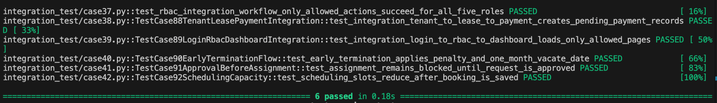
Figure 10.2 – Integration test run showing all integration tests passing after the fix.

